Abstract
This experiment determined the accuracy and precision of smartphone pressure sensors using the Phyphox app and modeled the relationship between atmospheric pressure and altitude. Data was collected across five floor levels in the stairwell of Planetary Hall. The sensors demonstrated high relative precision within 0.06 hPa of the group mean. Analysis revealed an experimental air density of $$1.5927 {\text{kg}\text{/}\text{m}}^{3}$ and an actual architectural floor height of approximately 5.30 meters.

Introduction
The experiment is motivated by the physical principle that atmospheric pressure decreases linearly with height over small vertical distances. This relationship is governed by the hydrostatic equation:
$$P=P_{0}-ρgy$$
where $$P$$ is pressure, $$ρ$$ is air density, $$g$$ is gravitational acceleration, and $$y$$ is height. Key principles include the Ideal Gas Law to determine theoretical air density for comparison.

Experiment
- Apparatus:
  - Four iPhones (models 13–16) equipped with Bosch barometers and the Phyphox software.
- Procedures:
- Sensor Characterization: Phones were placed stationary on a table for 13 seconds to measure internal noise and relative accuracy.
- Pressure vs. Altitude: Data was collected at a sample rate of 1 Hz by placing phones on the floor of each stairwell level from Floor 0 to Floor 4. An initial measurement of 395 cm was made for the distance of the of the floor of floor 3 to the floor of floor 4

Data and Analysis

Sensor Characterization
A relative accuracy for everyone was calculated by $\left|μ_{group}-μ_{ind}\right|$where $μ_{group}=\frac{1}{4}∑μ_{ind}$.
The relative accuracy shows how close a person's sensor is to an agreeable group value.
The low standard deviation values confirm that the internal "noise" or oscillation of the sensors was minimal during the 13-second collection window.
All sensors are within approximately 0.06 hPa of the group mean, indicating high precision from the manufacturer calibration between different iPhone models (13-16).
Member | Mean Pressure (hPa) | Standard Deviation (hPa) | Relative Accuracy (hPa)
Daksh | 1012.281 | 0.0017 | 0.058
Clarisse | 1012.285 | 0.004 | 0.062
Tim | 1012.277 | 0.007 | 0.054
Joel | 1012.281 | 0.0017 | 0.058

The table below is showing the precision of the sensors by taking the absolute difference of the standard deviations of each person compared to another. The
The reported precision concludes that random fluctuations are negligible
Device Comparison | Calculated Difference (hPa) | Reported Precision (hPa)
Daksh vs. Clarisse | 0.0055 | 0.006
Daksh vs. Tim | 0.0054 | 0.005
Daksh vs. Joel | 0 | 0
Clarisse vs. Tim | 0.0104 | 0.01
Clarisse vs. Joel | 0.0055 | 0.006
Tim vs. Joel | 0.0054 | 0.005

Modeling the relationship between Pressure vs height
Using the $\left|μ_{group}-μ_{ind}\right|$ we can visualize how far off an individual was from the agreed measurement.
This graph illustrates the relative accuracy of each device across the five floors. Error bars represent the internal stability (standard deviation) of each sensor. The consistent horizontal trends demonstrate that despite small absolute offsets $\left(≈0.06\text{ hPa}\right)$, the sensors maintain high relative precision throughout the experiment.
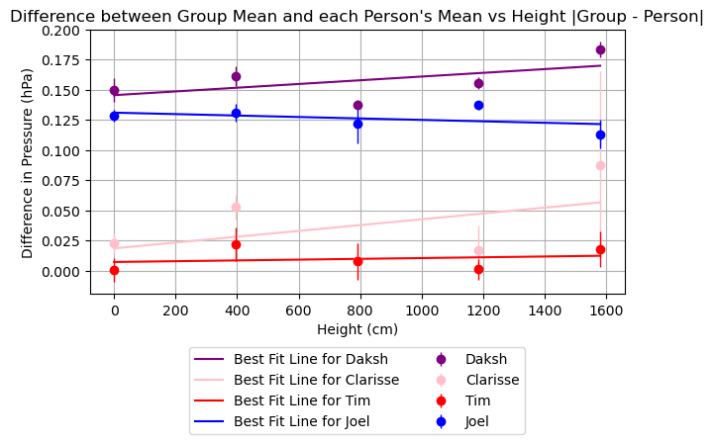

The data points represent the group average of four smartphone barometers at five floor levels. Error bars denote ±1 standard deviation of the measured pressure at each floor. The black line represents the linear best-fit $\left(P=-0.1562y+P_{0}\right)$, used to derive experimental air density.
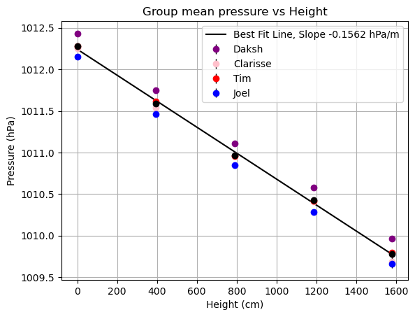
The slope finds an experimental air density of $1.5927 kg/m^{3}$ with a percent error of $32.37\%$ to the theoretical density of $1.2032 kg/m^{3}$.
Using $P=P_{0}-ρgy$, the derived air density from hPa to kg/m^3 is
$$ρ_{experimental}=\frac{-\left(slope×100\right)}{g}$$
The theoretical air density was found using ideal gas law at $T=20°C, M=0.02897 kg/mol, R=8.314 J/\left(mol⋅K\right), P=101227.93 Pa$

Results
- Slope: $-0.1562\text{ hPa}\text{/}\text{m}$
- Experimental Air Density: $1.5927 {\text{kg}\text{/}\text{m}}^{3}$
- Theoretical Air Density: $1.2032 {\text{kg}\text{/}\text{m}}^{3}$ (at ${20}^{∘\text{C}}$)
- Percent Error: $32.37\%$.
- Calculated Floor Height: 5.30 meters

Discussion
Height discrepancy
The height was estimated to be 395cm or about 4m between each floor. A 32% error in the slope suggest that the barometers think we are not changing each floor by 4m.
If we use $Δy=\frac{ΔP}{gρ_{theo}}$
We get 5.3m
- Sources of error: Active ventilation may have caused pressure gradients independent of altitude
- Conclusion: The barometric data indicates an actual average floor height of 5.30 meters. Although the floors were initially estimated at 4m, the measured pressure drop per floor $\left(0.6257\text{ hpa}\right)$ indicates a significantly greater vertical distance. While factors such as building ventilation (creating non-static gradients) could influence the results, the most robust physical explanation for the consistent pressure drop is that the architectural height of each floor is approximately 5.30 meters.

